Excel_assesment

1: Edit an Existing Query in Power Query
- Open the Excel file.
- Go to the Data tab.
- Click on Queries & Connections.
- On the right panel you will see a list of queries.
- Double click the query you want to edit OR right click the query and select Edit.
- Power Query Editor will open.
- Make the required changes from the Applied Steps panel.
- Click Close & Load to apply the changes back to Excel.

Fix Blank Column Heading for Pivot Table
- Open the Expenses sheet.
- Go to cell F4.
- Enter the column heading: Tax Code.
- Ensure every column in the dataset has a header so the Pivot Table can include all fields.

Filter Pivot Table Using Slicer
- Click anywhere inside the Pivot Table.
- Go to the PivotTable Analyze tab.
- Click Insert Slicer.
- Select the field named Account and click OK.
- A slicer will appear.
- Hold the CTRL key and select IS-375 and IS-390.
- The Pivot Table will now display supplier totals only for these accounts.

2: Extract Unique Sales Rep List Using Power Query
- Select the data table.
- Go to the Data tab.
- Click From Table/Range.
- Power Query Editor will open.
- Select the Sales Rep column.
- Go to the Home tab.
- Click Remove Rows and then select Remove Duplicates.
- Only unique Sales Rep names will remain.
- Click Close & Load to load the result into a new Excel sheet.

3. Filter the pivot table data with the slicer so that the supplier totals for only expenses that have been allocated to account IS-375 or account IS-390 are displayed in the pivot table.

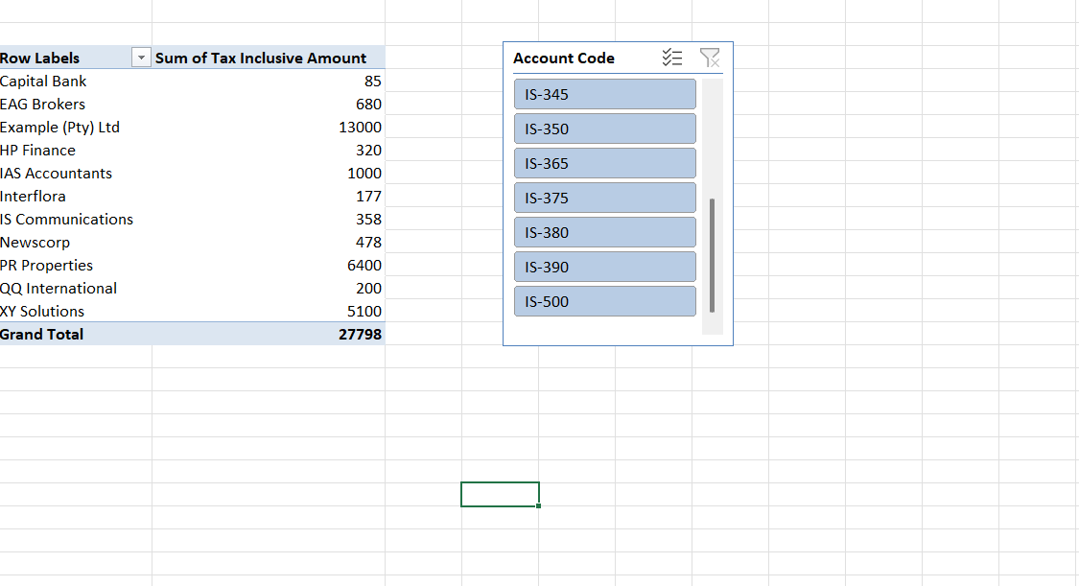

Question 2 : Replace Complex Excel Array Formulas with Simple Power Query Solution. 1) Goal is to extract a unique list of values from the Sales Rep Column, without using an Excel Array Formula.

